- 2200032991 Additional handson task
- Demonstrate implementation of Query Methods feature of Spring Data JPA
Use this command on the vs code to run the spring application and get the output
mvn spring-boot:run
Dependencies needed to be added
and keep you java at 17 in the pom.xml file or else you will get error
      - Spring Boot Starter Web
      - 2. Spring Boot Starter Data JPA
      - 3. H2 Database
      - Spring Boot Starter Parent (Defined in <parent>)
Next start your spring after you add the necessary dependencies
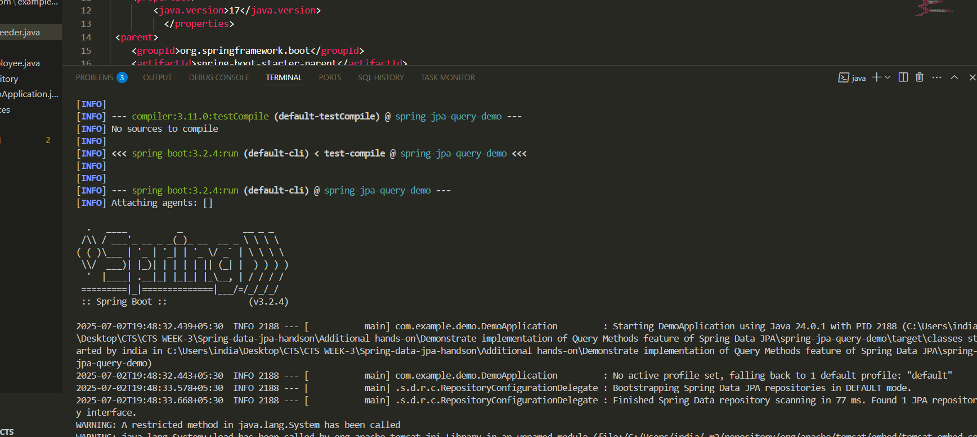

OUTPUT the data or the employees

